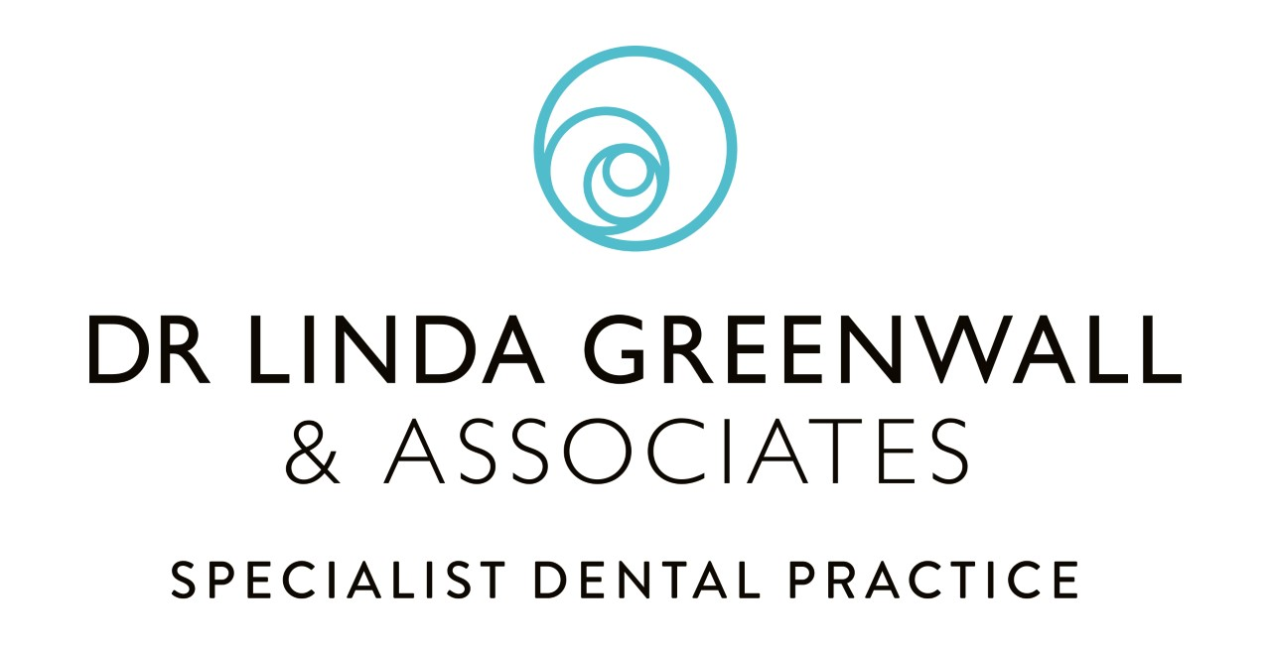
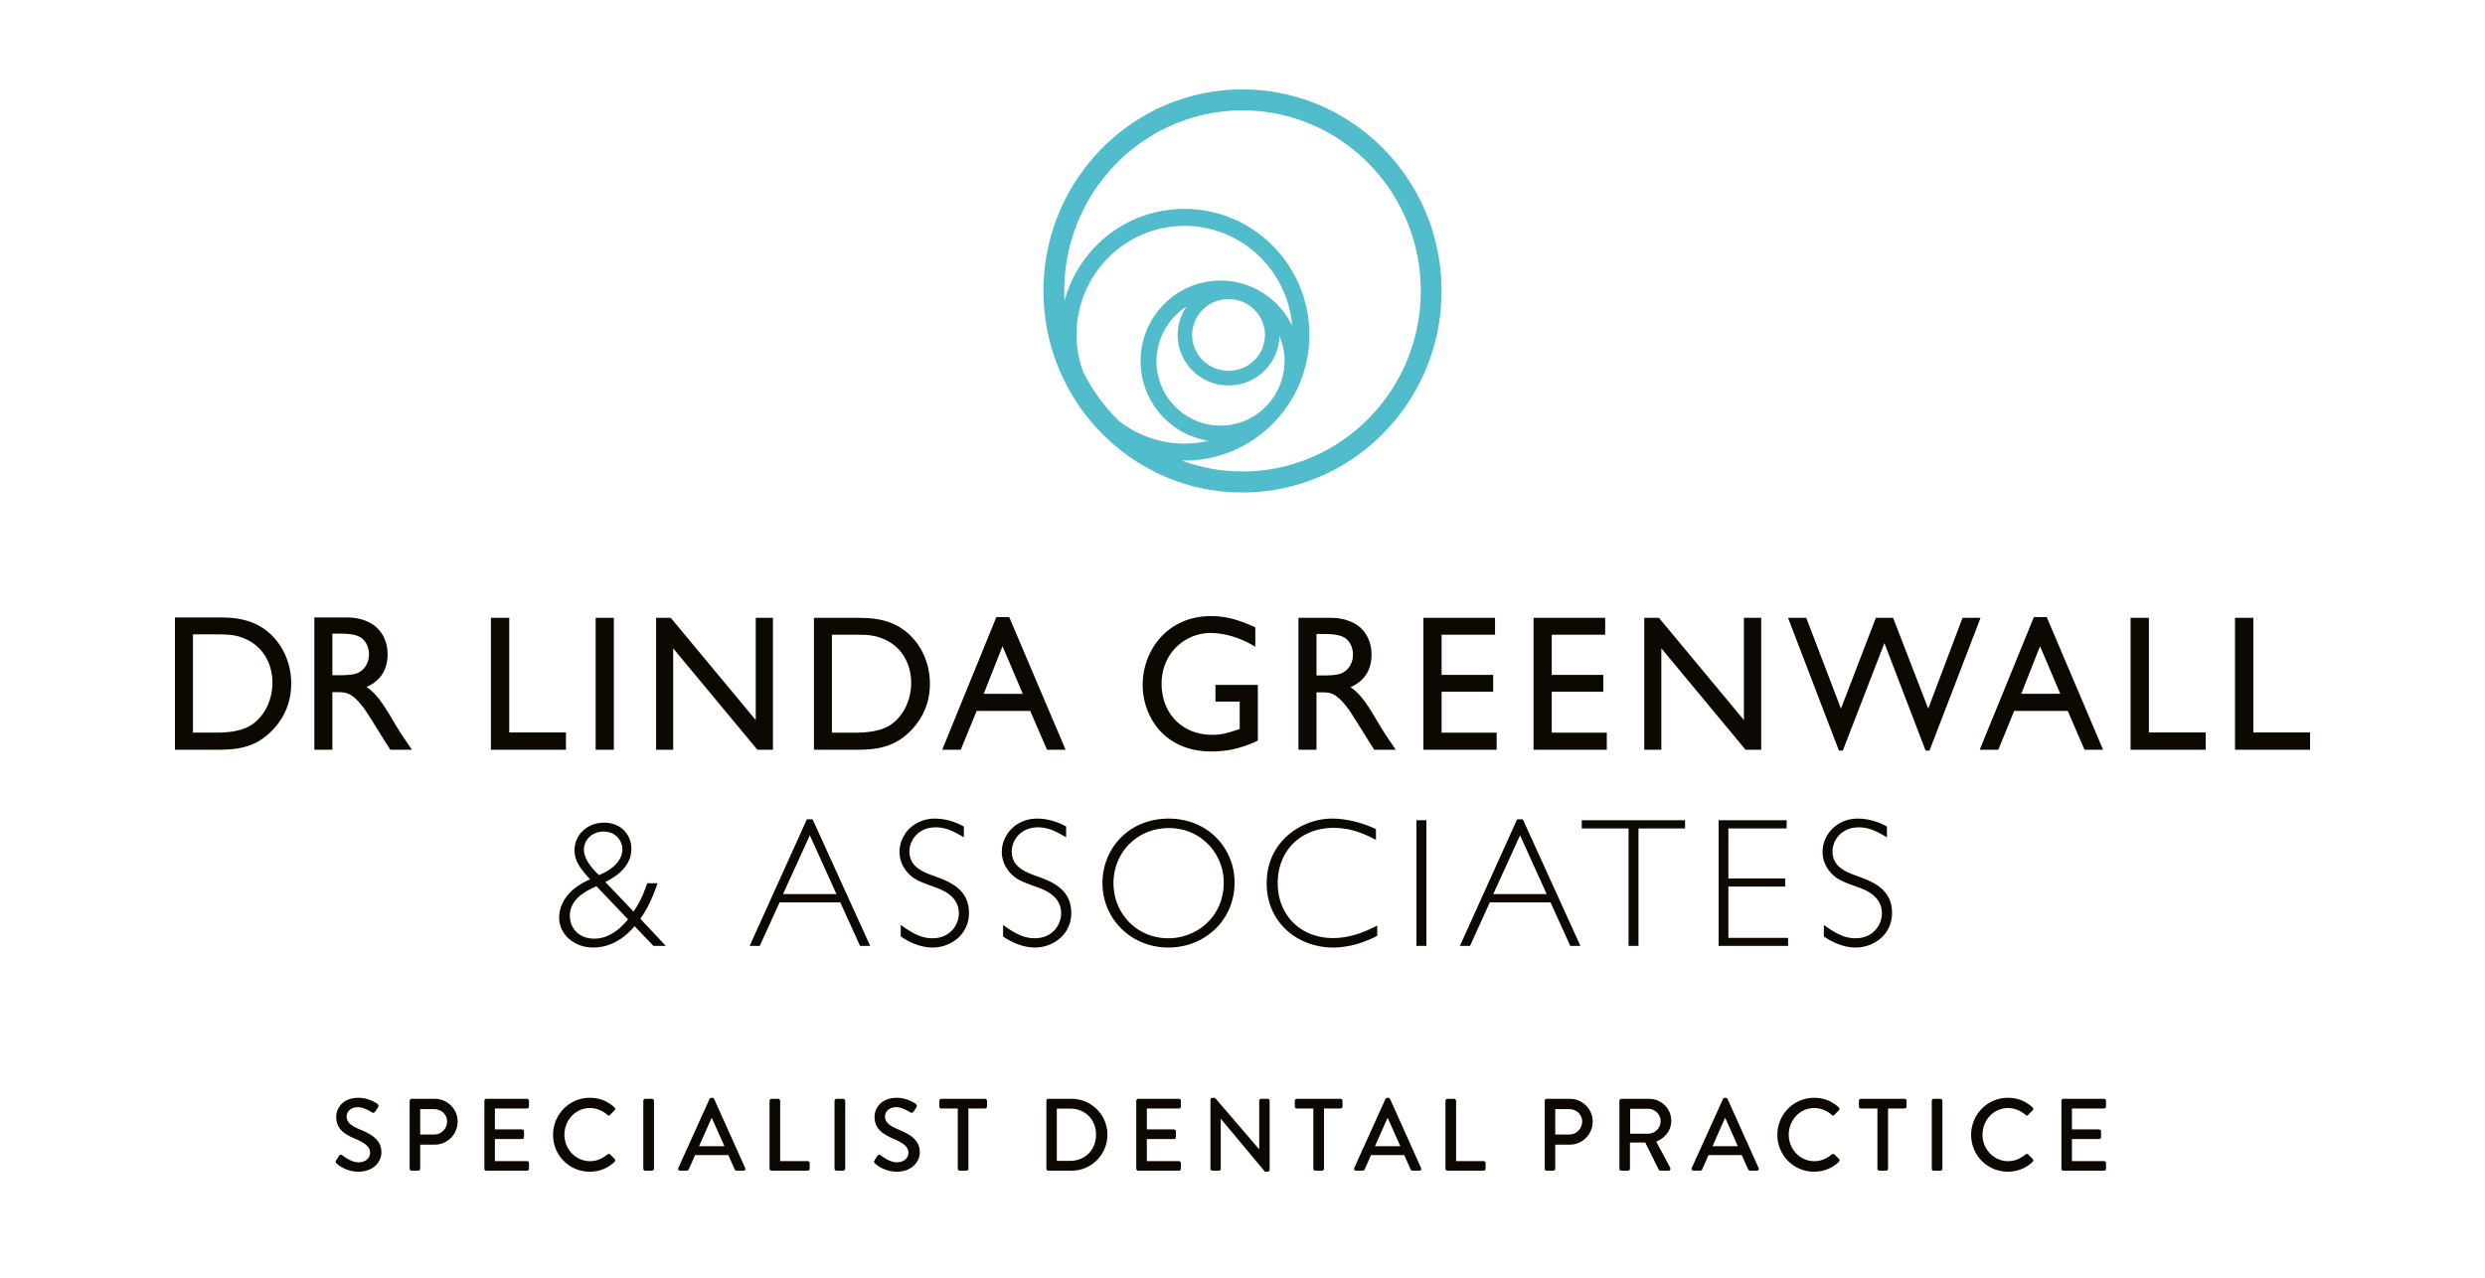
Tooth Whitening
Tooth whitening is a popular treatment to brighten and lighten your smile.

If I would like to whiten my teeth what should I do?
First we need to make sure tooth whitening is the right treatment for you, by carrying out a thorough examination of your gums, teeth and soft tissue (cheeks, lips, tongue and palate) radiographs (x-rays) may need to be taken to check for tooth decay or any infections that could affect the treatment. We take photographs and assess the current shade of your teeth. Once all the information is gathered a treatment plan is prepared and presented to you.
If you would like to continue with the treatment we will take some dental impressions and have some trays made especially for you, which we fit at a separate appointment. At the fit appointment, we will show and explain what you need to do and all the products you need will be given.
Here is some more information about tooth whitening treatment at Linda Greenwall & Associates

How long should I wear the trays for?
This depends on the original shade of your teeth. Dark or very yellow/ grey or tetracycline stained teeth will take longer to whiten than teeth which start off lighter. The darker your teeth, the longer your teeth will take to get lighter. Tetracycline stained teeth can take 6 months or up to one year to reach a lighter shade. Some teeth can whiten in one month.

What do I do if I have any sensitivity?
Sensitivity is the most common side effect of tooth whitening. This occurs usually after about the third day of treatment and can be anything from a mild awareness of your teeth to random shooting pains. We will guide you through various steps to help you manage any sensitivity during the treatment.

What happens if my teeth do not bleach evenly?
If your teeth have visible white spots before whitening, the spots will appear much whiter during the first few days of treatment, as you continue the contrast between the white spots and the rest of the tooth will be less and eventually unnoticeable. Special procedures such as Microabrasion or Icon can be carried out by the dentist if required. Ask your dentist about the procedure if you have any concerns.

How will my teeth feel?
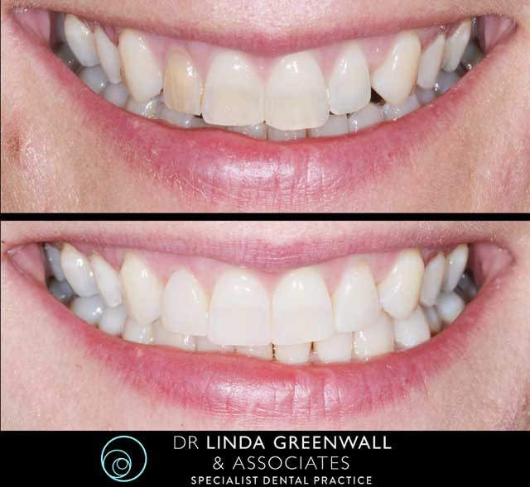
Normally the teeth feel very clean after the whitening procedure. The whitening materials also have an indirect effect on the gums, helping them to heal or improving the health of the gums. This is how the technique was discovered, as it was first used to heal gum irritation during orthodontic treatment.

What about my smile?
Your smile will appear brighter. It is very rare, but sometimes the teeth do not lighten at all. If this happens and you are wearing the whitening trays as recommended, you may need to try a different product or a slightly different concentration of the whitening gel. Discuss this with your dentist.
If you have white fillings on the front teeth, that match the existing shade of your teeth before you whiten them they may not match following the treatment. This is because your teeth can lighten, but the fillings do not. When the desired colour has been achieved, the dentist can replace these fillings with a lighter shade to match the new shade of your teeth. Normally the dentist will wait 2-3 weeks before changing the fillings.
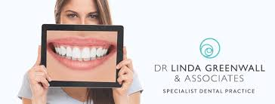
How long does the bleaching last? Will I have to bleach my teeth again?
Normally the lighter shade of your teeth keeps well. The effect is dependent on what has caused the discolouration in the first place. If you drink lots of tea, coffee, red wine, cola drinks the effect may darken slightly. Some patients do a top up treatment after 18-24months years. Some patients do not need to.

Does Bleaching harm the teeth or gums?
Safety studies have shown that whitening teeth under the instruction of dentist is perfectly safe for the teeth, cheeks, gums and soft tissues of the mouth. The whitening materials for home use are a neutral pH.
It is not, however, advisable to whiten your teeth if you smoke. It is best to stop smoking for at least 3 weeks before commencing with the treatment. Smoking causes the teeth to become darker, so the effect of the treatment diminishes.
Tooth whitening is not for everyone. There are some situations where tooth whitening is not appropriate, in these situations alternative treatments and techniques can be discussed with the dentist.

