Molar Incisor Hypomineralisation
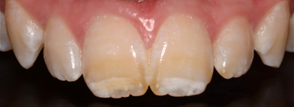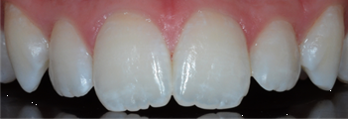
What is MOLAR INCISOR HYPOMINERALISATION?
Molar Incisor Hypomineralisation (MIH) is a defective tooth condition where enamel and dentine (the outer and middle layers of the tooth) are weaker and softer than normal.

This means that the teeth are prone breakages and decay. MIH is not usually noticed until the adult incisors (front teeth) or first molars erupt. One, some, or all of the first adult molars, incisors and sometimes the canines can be affected.

What Causes MIH?
MIH is thought to be caused by a disturbance in tooth development around the time of birth or in the first few years of life. Illness, traumatic child birth and repeat antibiotics are understood to be possible causes.

Is it common?
Around one in five (20%) people in the UK have the condition in one form or another. Some people may have a mild form and not realize it.

What can be done?
MIH has different severities and can be treated fairly minimally. In mild cases where the molar teeth are weak, special fluoride fillings can be placed to restore the weak enamel.

Whitening and resin infiltration can be undertaken on the anterior teeth to fade/eradicate the white and brown spots.

In other cases where the enamel is so weak and broken, crowns and composite bonded anterior fillings are required to restore the teeth.

More severe cases require extended intervention with extractions of the molar teeth and orthodontics to move the teeth to prevent gaps.

With all conditions early detection is the key, as the teeth can be strengthened with topical fluoride treatment and hygiene maintenance.

