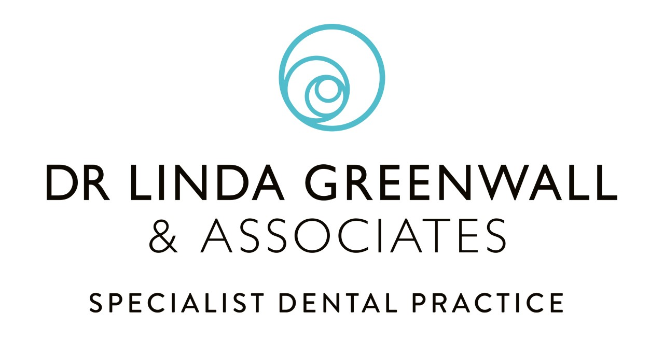
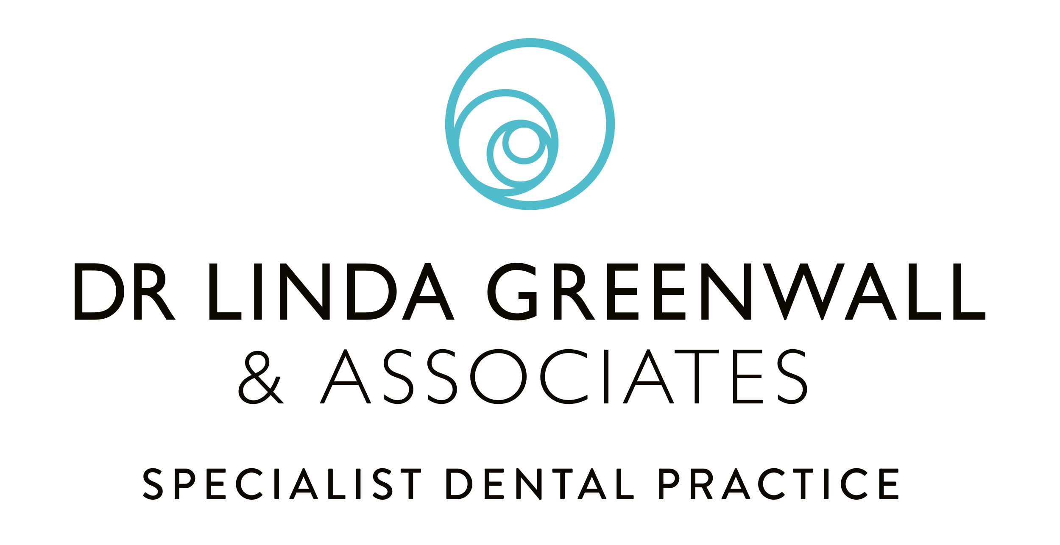

ALCOHOL

- There is no safe level of alcohol.
- It is advised not to drink more than 14 units per week – for both men and women.
- Spread these units over three or more days.
- 14 units looks like:
- 6 pints of beer
- 6 glasses of wine
One unit of alcohol is 10ml (1cl) by volume or 8g by weight of pure alcohol.
This is equivalent to:
- Half a pint of ordinary strength beer, lager or cider (3-4% alcohol by volume)
- A small pub measure (25ml) of spirits (40% alcohol by volume)
- A standard pub measure (50ml) of fortified wine such as sherry or port (20% alcohol by volume)
- Half a glass (87.5ml) of wine (12% by volume)
- 14 glasses of whisky (25mls)
- Drinking above the recommended limits could adversely affect our general and oral health by increasing the risk of:
- Oral cancer
- Dental trauma and facial injury either through accidental falls or violence.
- Tooth wear due to the acidity of drinks and sugar content.
- There is also some evidence that excess alcohol consumption is associated with periodontal disease.

